# Calculated Statistics for Paper

## **Which graph used:**

Profile | User Activity Report

## **Page to display graph:**

Student | User Profile

## **Statistic to display:**

Students being able to see their grade for each class they are in:

* Test averages into an overall grade in each assigned class.

## **Which graph used:**

Moris JS | Pie Chart

## **Page to display graph:**

Instructor | Test information page

## **Statistic to display:**

Instructors being able to see how well students did on a particular test

* Overall letter grades per test

## **Which graph used:**

Profile | User Activity Report

## **Page to display graph:**

User Profile

## **Statistic to display:**

* Overall signed/unsigned tests

## **Which graph used:**

Moris JS | Bar Chart Group

## **Page to display graph:**

Admin |

## **Statistic to display:**

* Per department | Course code | Test Average per section
* Each graph will display a department with courses that have varying section per course. Display the overall test average for each section

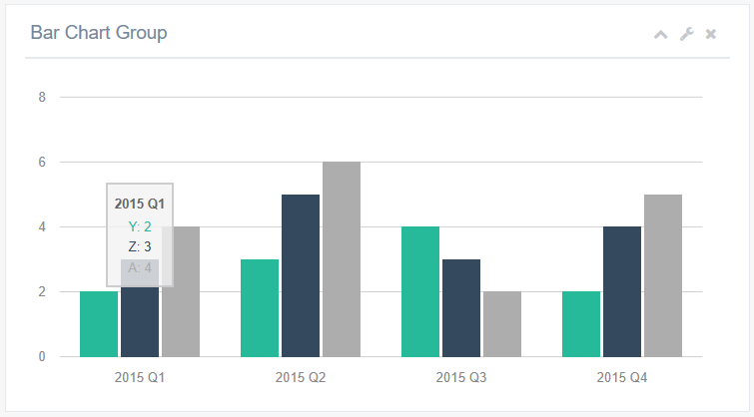

## **Which graph used:**

Other Charts | Easy Pie Chart

## **Page to display graph:**

Instructor | Test information

## **Statistic to display:**

* Signed/unsigned per test